Flight Ticketing Booking System

E - R Diagrams

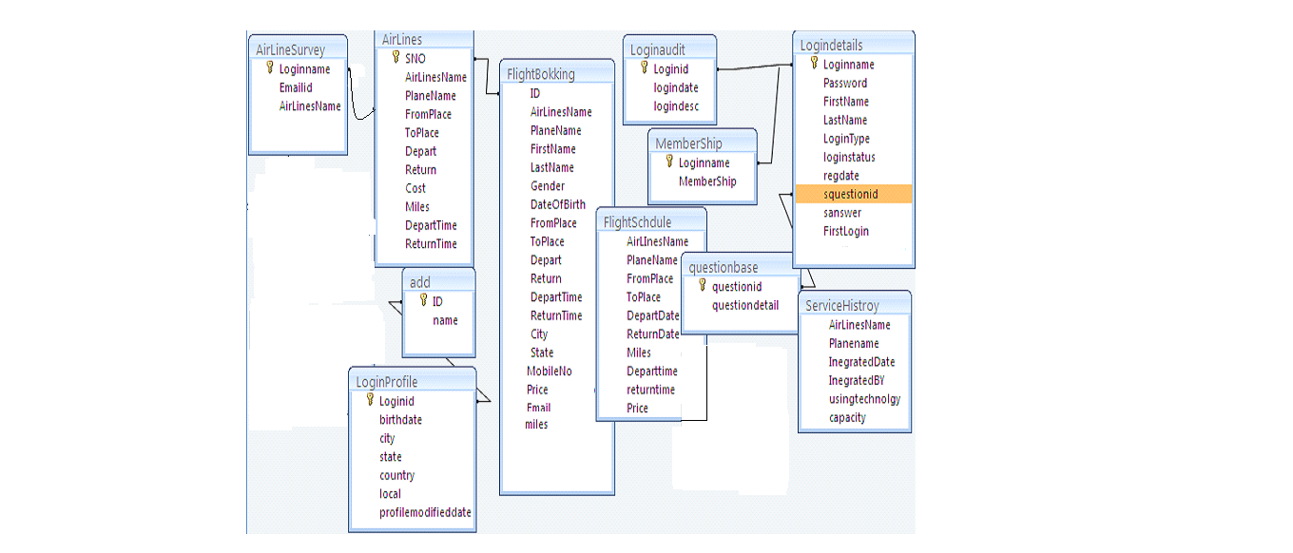

Keyed Relationships between Entities in an ER Diagram
UML Diagrams
UNIFIED MODELING LANGUAGE DIAGRAMS
The unified modeling language allows the software engineer to express an analysis model using the modeling notation that is governed by a set of syntactic semantic and pragmatic rules.

A UML system is represented using five different views that describe the system from distinctly different perspective. Each view is defined by a set of diagram, which is as follows.
  - User Model View
    - This view represents the system from the users perspective.
    - The analysis representation describes a usage scenario from the end-users perspective.

  - Structural model view
    - In this model the data and functionality are arrived from inside the system.
    - This model view models the static structures.

- Behavioral Model View
It represents the dynamic of behavioral as parts of the system, depicting the interactions of collection between various structural elements described in the user model and structural model view.

- Implementation Model View
In this the structural and behavioral as parts of the system are represented as they are to be built.

- Environmental Model View
In this the structural and behavioral aspects of the environment in which the system is to be implemented are represented.

UML is specifically constructed through two different domains they are:
- UML Analysis modeling, this focuses on the user model and structural model views of the system.
- UML design modeling, which focuses on the behavioral modeling, implementation modeling and environmental model views.

Use case Diagrams represent the functionality of the system from a user’s point of view. Use cases are used during requirements elicitation and analysis to represent the functionality of the system. Use cases focus on the behavior of the system from external point of view.

Actors are external entities that interact with the system. Examples of actors include users like administrator, bank customer …etc., or another system like central database.

Class Diagram
Class diagrams describe the structure of the system in terms of classes and objects. The servlet api class diagram will be as follows.

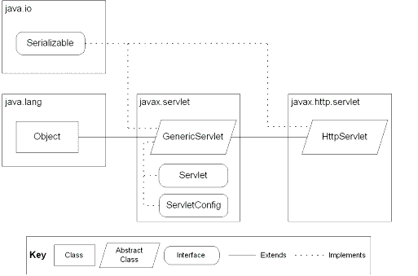
JSP: Implicit Objects

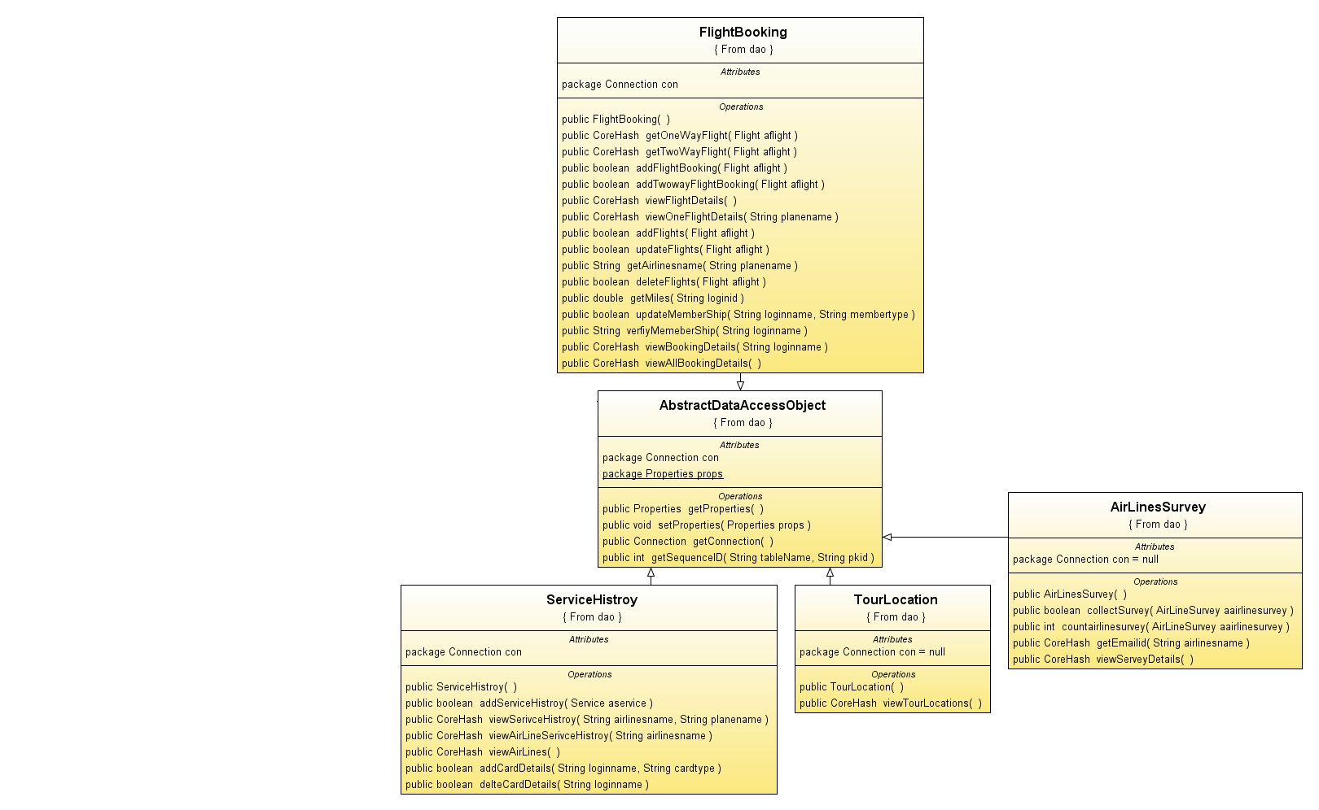

USE-CASE DIAGRAM

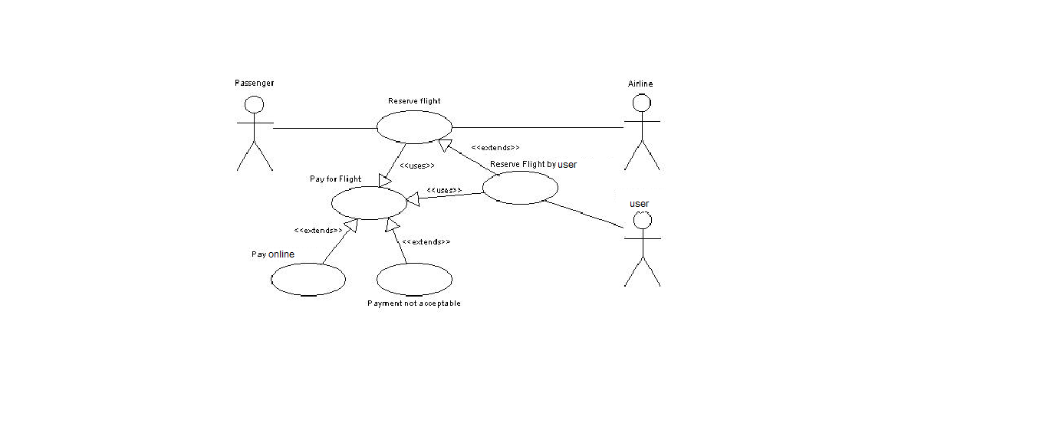
SEQUENCE DIAGRAM

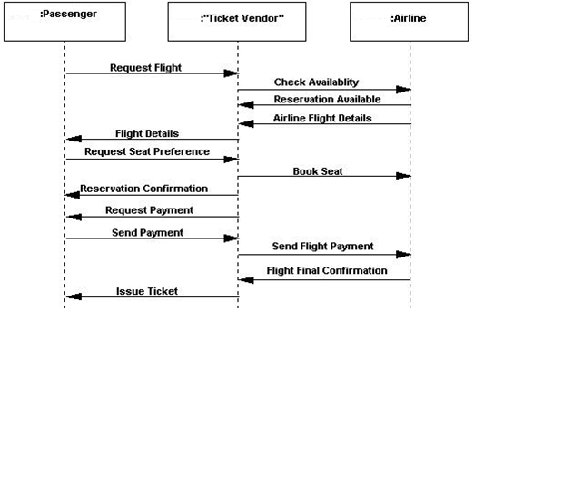

ACTIVITY DIAGRAMS

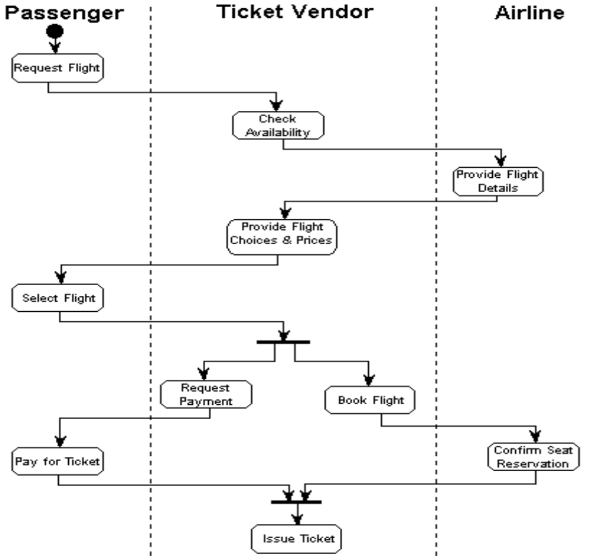

Component Diagram

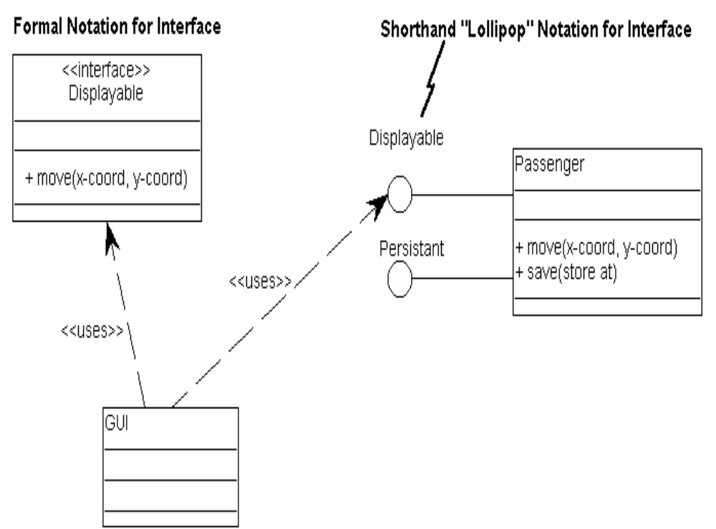

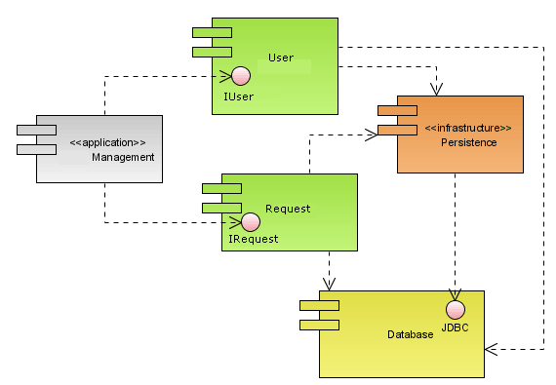
Deployment Diagram
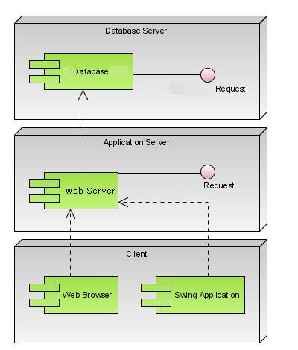

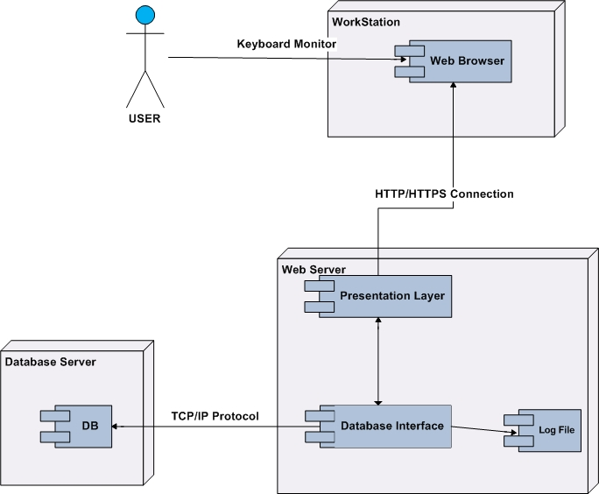

DATA DICTIONARY

Add
ColumnName | DataType | Size | Description
ID | AutoNumber |  | PK
Name | Text | 20 | NULL

Air Lines

ColumnName | DataType | Size | Constraints
SNO | AutoNumber | 5 | PK
AirLinesName | Text | 20 | NULL
PlaneName | Text | 20 | NULL
FromPlace | Text | 20 | NULL
ToPlace | Text | 20 | NULL
Depart | Date/Time |  | NULL
Return | Date/Time |  | NULL
Cost | Number | 5 | NULL
miles | Number | 5 | NULL
DepartTime | Date/Time |  | NULL
ReturnTime | Date/Time |  | NULL

Air Lines Survey

ColumnName | DataType | Size | Constraints
Loginname | Text | 20 | PK
Emailid | Text | 20 | NULL
AirLineName | Text | 20 | NULL
Reason | Text | 20 | NULL

Flight Booking

ColumnName | DataType | Size | Constraints
ID | Number | 4 | PK
AirLinesName | Text | 20 | NULL
PlaneName | Text | 20 | NULL
FromPlace | Text | 20 | NULL
ToPlace | Text | 20 | NULL
Depart | Text | 20 | NULL
Return | Text | 20 | NULL
DepartTime | Date/Time |  | NULL
ReturnTime | Date/Time |  | NULL
City | Text | 20 | NULL

Flight Schedule

ColumnName | DataType | Size | Constraints
AirLinesName | Text | 20 | NULL
PlaneName | Text | 20 | NULL
FromPlace | Text | 20 | NULL
ToPlace | Text | 20 | NULL
DepartDate | Date/Time |  | NULL
ReturnDate | Date/Time |  | NULL
Miles | Number | 4 | NULL
Departtime | Text | 20 | NULL
Returntime | Text | 20 | NULL
Price | Number | 4 | NULL

Login Audit

ColumnName | DataType | Size | Constraints
Loginid | Text | 10 | PK
logindate | Date/Time |  | NULL
logindesc | Text | 20 | NULL

Login Details
ColumnName | DataType | Size | Constraints
Loginname | Text | 20 | NULL
Password | Text | 6 | NULL
FirstName | Text | 20 | NULL
LastName | Text | 20 | NULL
LoginType | Text | 20 | NULL
Loginstatus | Text | 20 | NULL
regdate | Date/Time |  | NULL
squestionid | Text | 10 | FK
sanswer | Text | 20 | NULL
FirstLogin | Text | 20 | NULL

Login Profile

ColumnName | DataType | Size | Constraints
LoginId | Text | 10 | FK
BirthDate | Date/Time |  | NULL
City | Text | 10 | NULL
State | Text | 10 | NULL
Country | Text | 10 | NULL
Local | Text | 10 | NULL
ProfileModifieddate | Date/Time |  | NULL

Member Ship

ColumnName | DataType | Size | Constraints
Loginname | Text | 10 | NULL

Question base

ColumnName | DataType | Size | Constraints
QuestionId | Text | 4 | PK
Questiondetails | Text | 20 | NULL

Service History

ColumnName | DataType | Size | Constraints
AirLinesName | Text | 20 | NULL
Planename | Text | 20 | NULL
InegratedDate | Date/Time |  | NULL
InegratedBY | Text | 20 | NULL

